Lab Exercise 1: Create a Basic Deployment
apiVersion: apps/v1
kind: Deployment
metadata:
name: nginx-deploy
spec:
replicas: 2
selector:
matchLabels:
app: nginx
template:
metadata:
labels:
app: nginx
spec:
containers:
- name: nginx
image: nginx:1.14.2
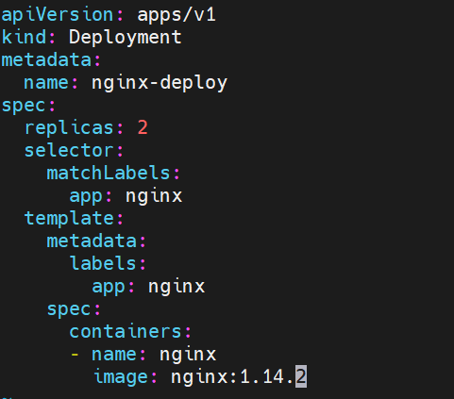

Lab Exercise 2: Update Deployment Image
Objective: Update the nginx server version.
- Task: Update the nginx image version in the "nginx-deploy" Deployment to nginx:1.17.9.
kubectl set image deployment/nginx-deploy nginx=nginx:1.18.0
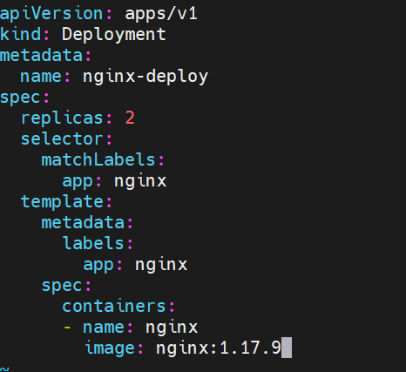
Solution: Update the Deployment manifest with the new image and then apply it using kubectl apply.
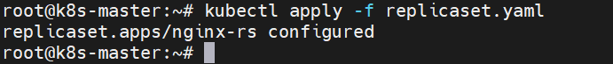

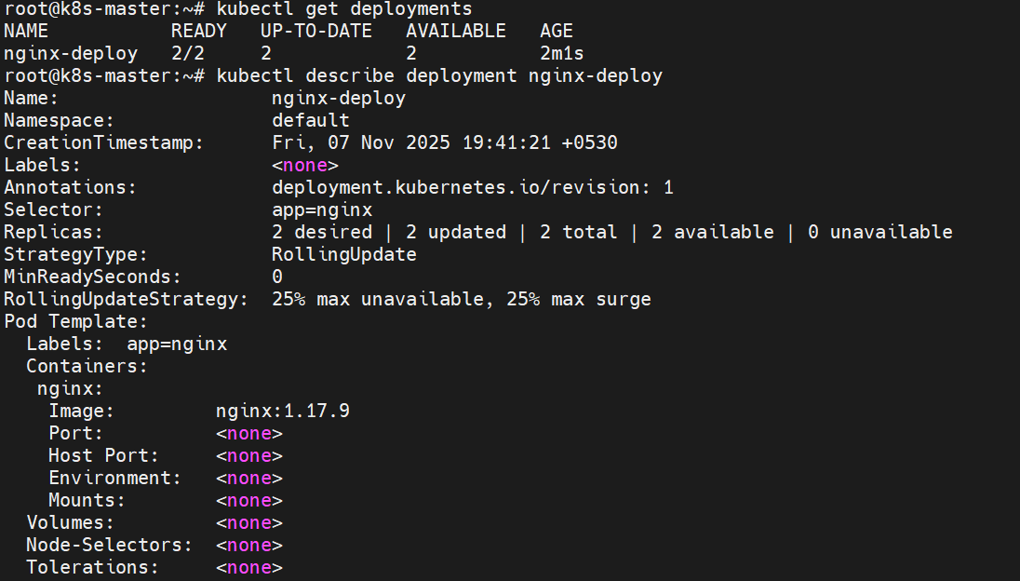

Lab Exercise 3: Rollback Deployment
Objective: Rollback the Deployment to a previous version.
- Task: Roll back the "nginx-deploy" Deployment to its previous version after updating the image in Exercise 2.
Solution:
kubectl rollout undo deployment/nginx-deploy
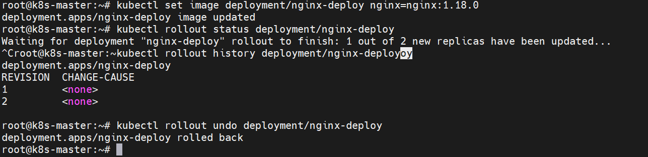

Lab Exercise 4: Scale Deployment
Objective: Manually scale the Deployment.
- Task: Scale the "nginx-deploy" Deployment to 5 replicas without modifying the manifest file.
Solution:
kubectl scale deployment nginx-deploy --replicas=5
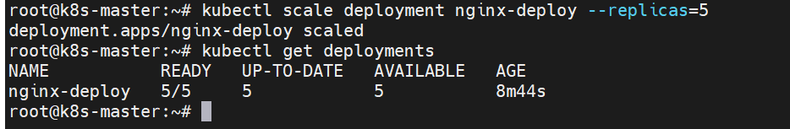

Lab Exercise 5: Pausing and Resuming Deployment
Objective: Learn to pause a deployment, update it, and then resume it.
- Task:
  - Pause the "nginx-deploy" Deployment.
  - Update the nginx image to nginx:1.18.0 without causing an immediate rollout.
  - Resume the deployment and watch the rollout of the new version.
Solution:
- Pause the Deployment:
kubectl rollout pause deployment/nginx-deploy
- Update the Deployment (for example, by modifying the manifest and applying it):
# ... (rest of the manifest remains unchanged)
spec:
containers:
- name: nginx
image: nginx:1.18.0
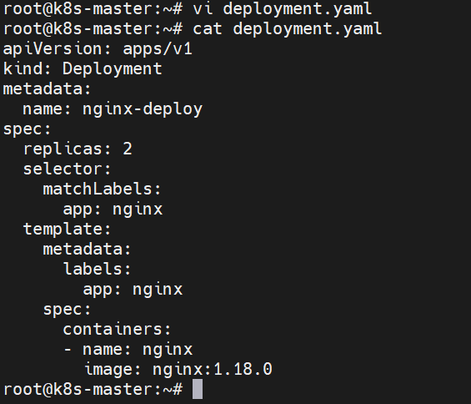
- Resume the Deployment:
kubectl rollout resume deployment/nginx-deploy
ment

To validate the results after each exercise, learners can use kubectl get deploy, kubectl describe deploy <deployment-name>, and other relevant kubectl commands.
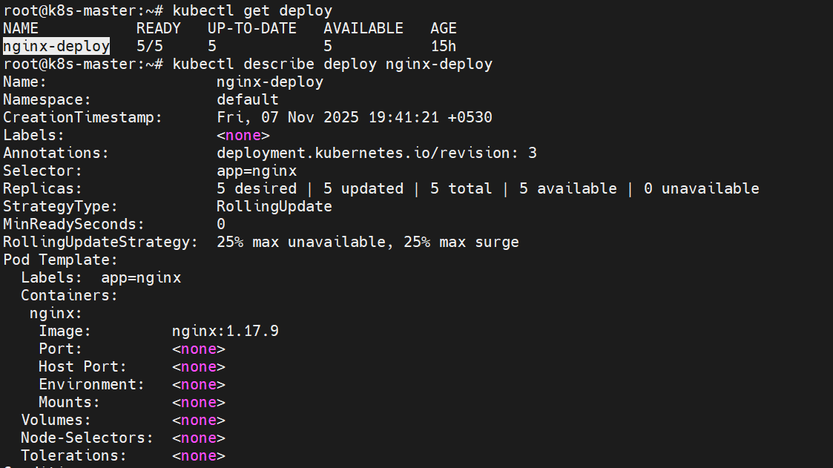

=====================================================

Lab Exercise: Kubernetes Deployment for Image Update
Objective: This lab exercise will guide you through updating the container image of a Kubernetes deployment.
Prerequisites:
- A running Kubernetes cluster (Minikube or any cloud provider’s Kubernetes service).
- kubectl CLI tool installed and configured to interact with your cluster.

Steps:
- Create a Sample Deployment
If you don’t already have a deployment to work with, let’s create a sample deployment:
kubectl create deployment nginx-deployment –image=nginx:1.17.10

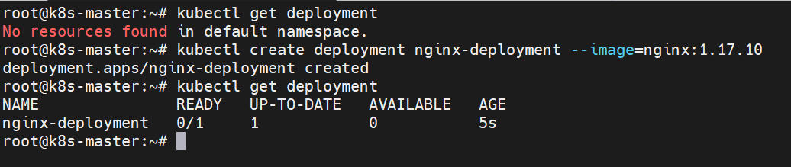
This creates a deployment named nginx-deployment using the nginx:1.17.10 image.

2. Verify the Deployment
To ensure the deployment was created successfully:
kubectl get deployments

3. Update the Image for the Deployment
To update the image for our deployment:
kubectl set image deployment/nginx-deployment nginx=nginx:1.19.6

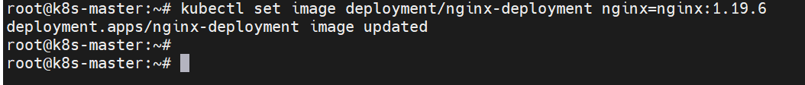
This updates the image for the nginx-deployment to nginx:1.19.6.
- Check the Status of the Deployment Update
To observe the rolling update:
kubectl rollout status deployment/nginx-deployment

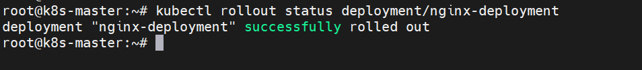

5. Verify the Updated Image
To check the image of the running container(s):
kubectl get deployment nginx-deployment -o=jsonpath='{$.spec.template.spec.containers[:1].image}'

This should show nginx:1.19.6.

6. Rollback (Optional)
If there's any issue with the new version, Kubernetes allows you to roll back to the previous version:
kubectl rollout undo deployment/nginx-deployment

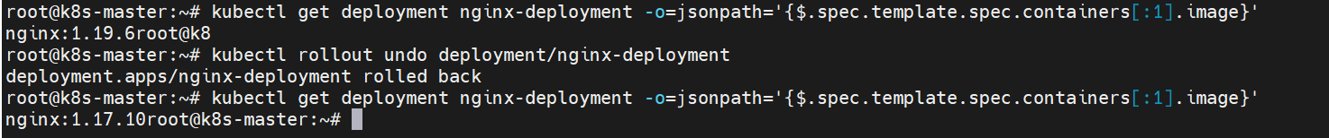
This rolls back the deployment to the previous version.

7. Cleanup
Once you've completed the exercise, clean up the resources:
kubectl delete deployment nginx-deployment

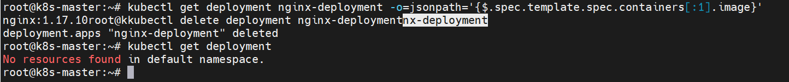

Conclusion
At this point, you should have successfully updated the container image of a Kubernetes deployment, verified the update, and optionally rolled back to a previous version. Updating container images is a fundamental operation in Kubernetes, and mastering it will help you manage and maintain applications effectively.
======================================================
Lab Exercise: Kubernetes Deployment with --revision
Objective: In this lab exercise, you will dive deep into Kubernetes' deployment mechanism and learn how to inspect specific revisions of a deployment and roll back to them if necessary.

Prerequisites:
- A running Kubernetes cluster (Minikube or any cloud provider's Kubernetes service).
- kubectl CLI tool installed and configured to interact with your cluster.

Steps:

1. Create a Sample Deployment
If you don't already have a deployment to work with, let's create a sample deployment:
kubectl create deployment nginx-deployment --image=nginx:1.17.10

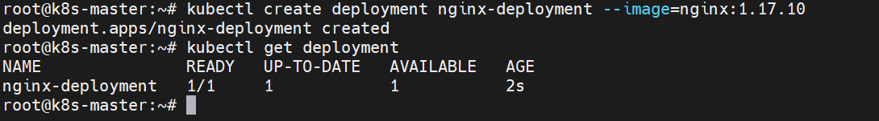
This creates a deployment named nginx-deployment using the nginx:1.17.10 image.

2. Verify the Deployment
To ensure the deployment was created successfully:
kubectl get deployments

3. Update the Deployment's Image
Let's make a few updates to the deployment's image to generate multiple revisions:
First update:
kubectl set image deployment/nginx-deployment nginx=nginx:1.19.1
Second update:
kubectl set image deployment/nginx-deployment nginx=nginx:1.19.2

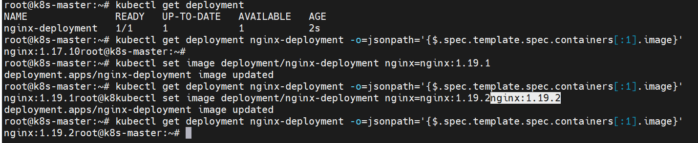
- Inspect Deployment Revisions
To list the rollout history of our deployment:
kubectl rollout history deployment/nginx-deployment
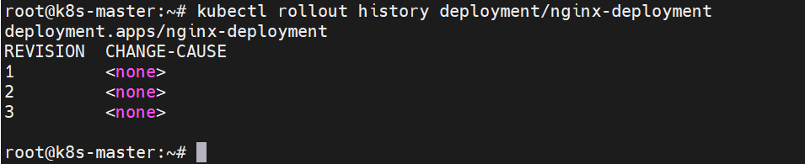
You should see two revisions listed with their respective change-cause.
To inspect details of a specific revision, use:
kubectl rollout history deployment/nginx-deployment –revision=1
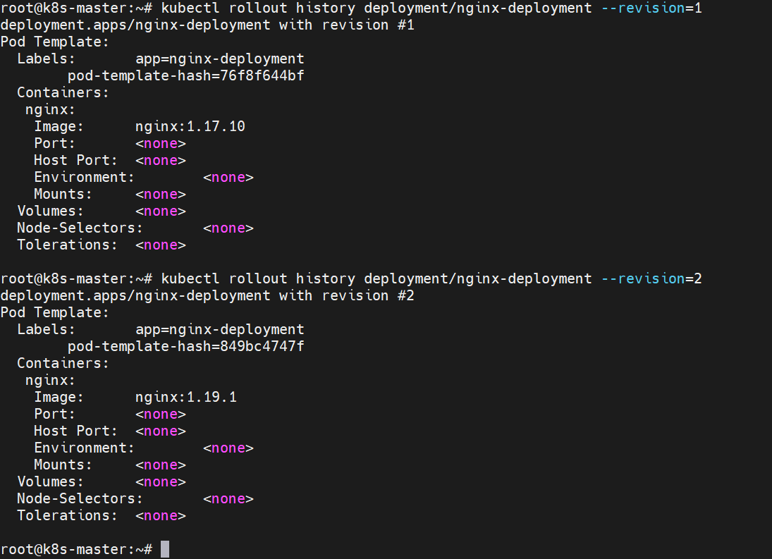
Replace 1 with the revision number you're interested in.

5. Roll Back to a Specific Revision
Let's say you want to roll back to the first revision:
kubectl rollout undo deployment/nginx-deployment --to-revision=1

6. Verify the Rollback
To check the image of the running container(s) post-rollback:
kubectl get deployment nginx-deployment -o=jsonpath='{$.spec.template.spec.containers[:1].image}'

This should show nginx:1.17.10.
- Cleanup
Once you’ve completed the exercise, clean up the resources:
kubectl delete deployment nginx-deployment

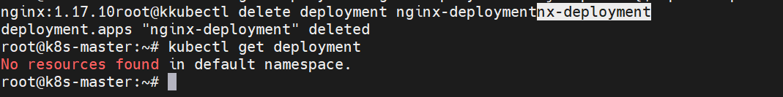

Conclusion
You have successfully explored the revision-specific aspects of a Kubernetes deployment. Understanding how to inspect and roll back to specific revisions is crucial for managing applications in production and ensuring reliability.

===========================================

